Group # | 05 |  | Week ending:  (Saturday) | 3/25/17 |  |  |  |  | Report # |  |  | 10
Project Title: |  | Spectrum Sensing and Signal Identification using USRP
Group Leader: |  | Thomas Wright |  |  | Advisor: | Bruce McNair
Sponsor/Client: |  | MITRE Corporation
Total number of person-hours spent on project by group during past week: |  |  |  |  |  |  |  | 25
Is project on schedule? |  |  |  |  | Yes |  | [X] |  |  | No | [ ]

Weekly status:

We have been working on developing the simple GUI to be displayed to the visitors on Design Day and identified that open-source programs like IronPython will help us design our display model feasible. We are also making changes to our financial analysis and refining our elevator pitch as necessary as well.

“I Pledge my Honor that I have abided by the Stevens Honor System.”

Andrew Guthrie Joseph Pang Kunal Patel
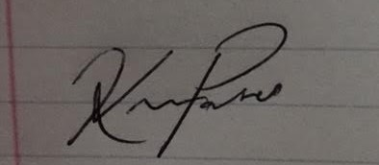
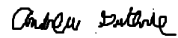


Thomas Wright Vijayrahul Raja
