Group # | 05 |  | Week ending:  (Saturday) | 4/01/17 |  |  |  |  | Report # |  |  | 11
Project Title: |  | Spectrum Sensing and Signal Identification using USRP
Group Leader: |  | Thomas Wright |  |  | Advisor: | Bruce McNair
Sponsor/Client: |  | MITRE Corporation
Total number of person-hours spent on project by group during past week: |  |  |  |  |  |  |  | 25
Is project on schedule? |  |  |  |  | Yes |  | [X] |  |  | No | [ ]

Weekly status:

We have been improving the features of our developed Adaptive Sensing model from major recommendations from our advisor and from our own analysis. We have also submitted the initial Elevator Pitch video to be given feedback from our TG professor.

“I Pledge my Honor that I have abided by the Stevens Honor System.”

Andrew Guthrie Joseph Pang Kunal Patel
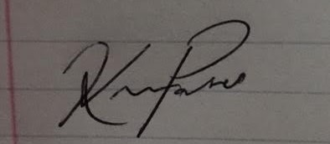



Thomas Wright Vijayrahul Raja

