Group # | 05 |  | Week ending:  (Saturday) | 4/08/17 |  |  |  |  | Report # |  |  | 12
Project Title: |  | Spectrum Sensing and Signal Identification using USRP
Group Leader: |  | Thomas Wright |  |  | Advisor: | Bruce McNair
Sponsor/Client: |  | MITRE Corporation
Total number of person-hours spent on project by group during past week: |  |  |  |  |  |  |  | 25
Is project on schedule? |  |  |  |  | Yes |  | [X] |  |  | No | [ ]

Weekly status:

We are continuously improving our prototype especially on machine learning implementations and making fixes to present the model on Design Day. We are also working with our TG professor refining our elevator pitch.

“I Pledge my Honor that I have abided by the Stevens Honor System.”

Andrew Guthrie Joseph Pang Kunal Patel
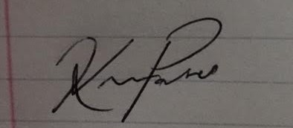
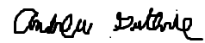


Thomas Wright Vijayrahul Raja
