Group # | 05 |  | Week ending:  (Saturday) | 4/15/17 |  |  |  |  | Report # |  |  | 13
Project Title: |  | Spectrum Sensing and Signal Identification using USRP
Group Leader: |  | Thomas Wright |  |  | Advisor: | Bruce McNair
Sponsor/Client: |  | MITRE Corporation
Total number of person-hours spent on project by group during past week: |  |  |  |  |  |  |  | 25
Is project on schedule? |  |  |  |  | Yes |  | [X] |  |  | No | [ ]

Weekly status:

We have been performing statistical analysis on our developed model to improve its features and have also submitted the required Wildcard pitch for our TG course. For the GUI, we are using Tkinter python package, to show the inputs and desired outputs of our Adaptive Spectrum Sensing system.

“I Pledge my Honor that I have abided by the Stevens Honor System.”

Andrew Guthrie Joseph Pang Kunal Patel
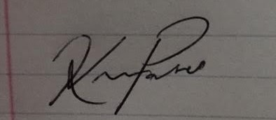
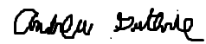


Thomas Wright Vijayrahul Raja
