Group # | 05 |  | Week ending:  (Saturday) | 4/22/17 |  |  |  |  | Report # |  |  | 14
Project Title: |  | Spectrum Sensing and Signal Identification using USRP
Group Leader: |  | Thomas Wright |  |  | Advisor: | Bruce McNair
Sponsor/Client: |  | MITRE Corporation
Total number of person-hours spent on project by group during past week: |  |  |  |  |  |  |  | 25
Is project on schedule? |  |  |  |  | Yes |  | [X] |  |  | No | [ ]

Weekly status:

We performed different accuracy tests on our model and are constantly adding new features to be displayed on the Design Day. We are also improving our Tkinter python GUI. Additionally, our team presented our current model to the incoming students in the Admitted Students Weekend event.

“I Pledge my Honor that I have abided by the Stevens Honor System.”

Andrew Guthrie Joseph Pang Kunal Patel
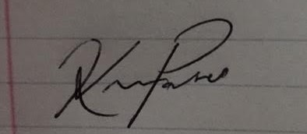
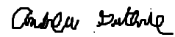


Thomas Wright Vijayrahul Raja
