Group # | 05 |  | Week ending:  (Saturday) | 4/29/17 |  |  |  |  | Report # |  |  | 15
Project Title: |  | Spectrum Sensing and Signal Identification using USRP
Group Leader: |  | Thomas Wright |  |  | Advisor: | Bruce McNair
Sponsor/Client: |  | MITRE Corporation
Total number of person-hours spent on project by group during past week: |  |  |  |  |  |  |  | 25
Is project on schedule? |  |  |  |  | Yes |  | [X] |  |  | No | [ ]

Weekly status:

We are finishing up adding new features in our model and fixing errors. Most of the trial and error testing is done for achieving accuracy of the expected output. We have also been designing our poster board, pamphlet and other things to be displayed on Design Day this week.

“I Pledge my Honor that I have abided by the Stevens Honor System.”

Andrew Guthrie Joseph Pang Kunal Patel
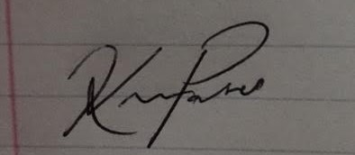
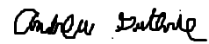


Thomas Wright Vijayrahul Raja
