Group # | 05 |  | Week ending:  (Saturday) | 1/30/17 |  |  |  |  | Report # |  |  | 2
Project Title: |  | Spectrum Sensing and Signal Identification using USRP
Group Leader: |  | Thomas Wright |  |  | Advisor: | Bruce McNair
Sponsor/Client: |  | MITRE Corporation
Total number of person-hours spent on project by group during past week: |  |  |  |  |  |  |  | 10
Is project on schedule? |  |  |  |  | Yes |  | [X] |  |  | No | [ ]

Weekly status:

Our team was mainly working on developing a business idea for TG while working on improving the prototype. We also analyzed the areas that needs specific attention like machine learning algorithms and other key components necessary for the model. We have begun our weekly team meetings, weekly lab time, and weekly advisor meetings.

“I Pledge my Honor that I have abided by the Stevens Honor System.”

Andrew Guthrie Joseph Pang Kunal Patel
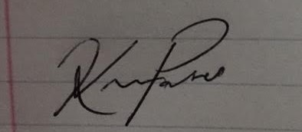
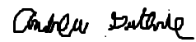


Thomas Wright Vijayrahul Raja
