Group # | 05 |  | Week ending:  (Saturday) | 2/11/17 |  |  |  |  | Report # |  |  | 4
Project Title: |  | Spectrum Sensing and Signal Identification using USRP
Group Leader: |  | Thomas Wright |  |  | Advisor: | Bruce McNair
Sponsor/Client: |  | MITRE Corporation
Total number of person-hours spent on project by group during past week: |  |  |  |  |  |  |  | 25
Is project on schedule? |  |  |  |  | Yes |  | [X] |  |  | No | [ ]

Weekly status:

Our team set up and performed an end to end prototype test by piping a known FM stream to the RF front ends, and letting the software identify the signal, push it to a queue, and capture I/Q data. The samples were then passed to the developed machine learning algorithms to optimize the collected I/Q data by performing an FM (Frequency Modulation) test. We also worked on revising our executive summary needed for our elevated pitch.

“I Pledge my Honor that I have abided by the Stevens Honor System.”

Andrew Guthrie Joseph Pang Kunal Patel
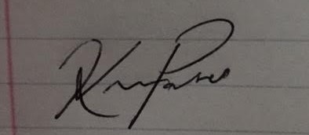
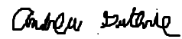


Thomas Wright Vijayrahul Raja
