Group # | 05 |  | Week ending:  (Saturday) | 2/18/17 |  |  |  |  | Report # |  |  | 5
Project Title: |  | Spectrum Sensing and Signal Identification using USRP
Group Leader: |  | Thomas Wright |  |  | Advisor: | Bruce McNair
Sponsor/Client: |  | MITRE Corporation
Total number of person-hours spent on project by group during past week: |  |  |  |  |  |  |  | 25
Is project on schedule? |  |  |  |  | Yes |  | [X] |  |  | No | [ ]

Weekly status:

Our team did the first successful test of the model last week. Initially,we streamed audio samples from the internet, FM modulated them, and transmitted back into the USRPs. One of the radios found the signal, pushed the signal characteristics to a queue, where the other radio, waiting for the queue, tuned to the appropriate frequency and sampling rate and captured the appropriate I/Q samples. These samples were passed to the machine learning algorithms where they were identified as the FM samples. This entire process took approximately 0.55 seconds and is being further analyzed by our team to obtain efficiency and accuracy.

“I Pledge my Honor that I have abided by the Stevens Honor System.”

Andrew Guthrie Joseph Pang Kunal Patel
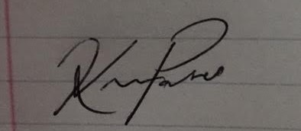
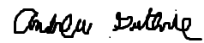


Thomas Wright Vijayrahul Raja
