Group # | 05 |  | Week ending:  (Saturday) | 3/04/17 |  |  |  |  | Report # |  |  | 7
Project Title: |  | Spectrum Sensing and Signal Identification using USRP
Group Leader: |  | Thomas Wright |  |  | Advisor: | Bruce McNair
Sponsor/Client: |  | MITRE Corporation
Total number of person-hours spent on project by group during past week: |  |  |  |  |  |  |  | 25
Is project on schedule? |  |  |  |  | Yes |  | [X] |  |  | No | [ ]

Weekly status:

We have continued testing our model, found couple of bugs in the code, and have been finding fixes for each of them.We have also continued working on our GUI and also other detection algorithms. Improvements in the business models and elevator pitch for the TG course had been made as well.

“I Pledge my Honor that I have abided by the Stevens Honor System.”

Andrew Guthrie Joseph Pang Kunal Patel
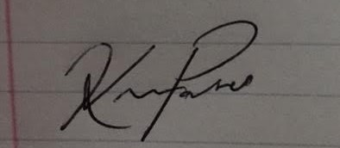
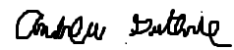


Thomas Wright Vijayrahul Raja
