Group # | 05 |  | Week ending:  (Saturday) | 3/11/17 |  |  |  |  | Report # |  |  | 8
Project Title: |  | Spectrum Sensing and Signal Identification using USRP
Group Leader: |  | Thomas Wright |  |  | Advisor: | Bruce McNair
Sponsor/Client: |  | MITRE Corporation
Total number of person-hours spent on project by group during past week: |  |  |  |  |  |  |  | 25
Is project on schedule? |  |  |  |  | Yes |  | [X] |  |  | No | [ ]

Weekly status:

We met our TG professor to discuss our elevator pitch outline and also explained the developments we made on our current model. We also requested his suggestions for our business model and about any major constraints that may exist.

“I Pledge my Honor that I have abided by the Stevens Honor System.”

Andrew Guthrie Joseph Pang Kunal Patel
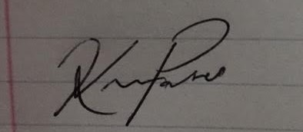
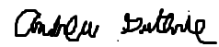


Thomas Wright Vijayrahul Raja
