Group # | 05 |  | Week ending:  (Saturday) | 3/18/17 |  |  |  |  | Report # |  |  | 9
Project Title: |  | Spectrum Sensing and Signal Identification using USRP
Group Leader: |  | Thomas Wright |  |  | Advisor: | Bruce McNair
Sponsor/Client: |  | MITRE Corporation
Total number of person-hours spent on project by group during past week: |  |  |  |  |  |  |  | 25
Is project on schedule? |  |  |  |  | Yes |  | [X] |  |  | No | [ ]

Weekly status:

We worked on our midterm report ( adding necessary information to our final report submitted in the Fall) . We are also currently working on developing the website to include all the required reports and other key components. Moreover, for the Design day, we are working on developing a GUI in C# so that it will be very easy for the visitors to get a simple visualization of our model.

“I Pledge my Honor that I have abided by the Stevens Honor System.”

Andrew Guthrie Joseph Pang Kunal Patel
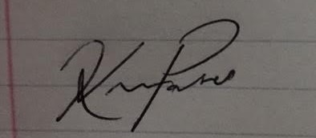
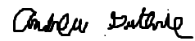


Thomas Wright Vijayrahul Raja
